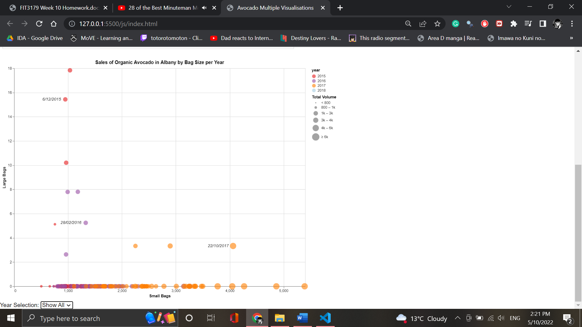

Multiple Visualisations LINK: <https://tngu0105.github.io/3179/>

**The domain of your visualisation**

* This visualisation appeals to the demographic of people in the USA (likely trendy teens/millennials or people who simply love Avocado with a passion) who have a strong interest in the market movements of this vegetable.

**The visualised dataset**

* The data set compiled by Justin Kiggins from Kaggle comprises ordinal variables like date and year, quantitative variables like average price, total volume and avocado’s with a specific tag sold, and nominal variables like region and type.

**Data transformation that you applied (if any)**

* Other than manually adding longitude & latitude values, as well as removing rows meant for aggregated totals since they appeared invalid, no other transformations were applied.

**A justification for the type of map idiom used.**

* The bubble map was opted for over other idioms because I wanted to describe multiple qualities associated with the avocado on a single visualisation. With the Bubble, I could not only specify two quantitative elements, but also the categorical aspect of the Avocado sale and even the frequency of this specific order on that date.